Grade 7 Accelerated · Unit 5 · Lessons 8–9  Converting Mass, Area and Volume  Independent Set 5.08 | Name______________________  Date______________________  Period____________________

Six questions, on your own, in silence. Show the step that does the work.
1. . How many kilograms is 30 lb?

2. 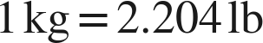. How many pounds is 25 kg?

3. 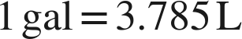. How many liters is 6 gal?

4. . How many square inches is 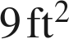?

5.  and . How many liters is 24 fl oz?

6. . How many square meters is 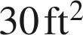? (Round to two places.)

